**Molecule Polarity**

In this activity you will use a PhET simulation to explore [molecule polarity](https://phet.colorado.edu/en/simulation/molecule-polarity).

**Part I: What factors affect molecule polarity?**

1. Explore the Molecule Polaritysimulation for a few minutes with a partner. In each of the three tabs, try to find all of the controls and figure out how they work.

**Two Atoms** tab (Bond Polarity)

1. Describe all of the ways you can change the polarity of the two-atom molecule.

Electronegativity

1. Explain how the representations below help you understand molecule polarity.

Bond dipole: an arrow that quantizes the polarity (the difference between two electronegativities) and points to the negative.

Partial Charges: shows the polarity

Electrostatic Potential: shows the polarity using red and blue.

Electron Density: the magnitude of polarity.

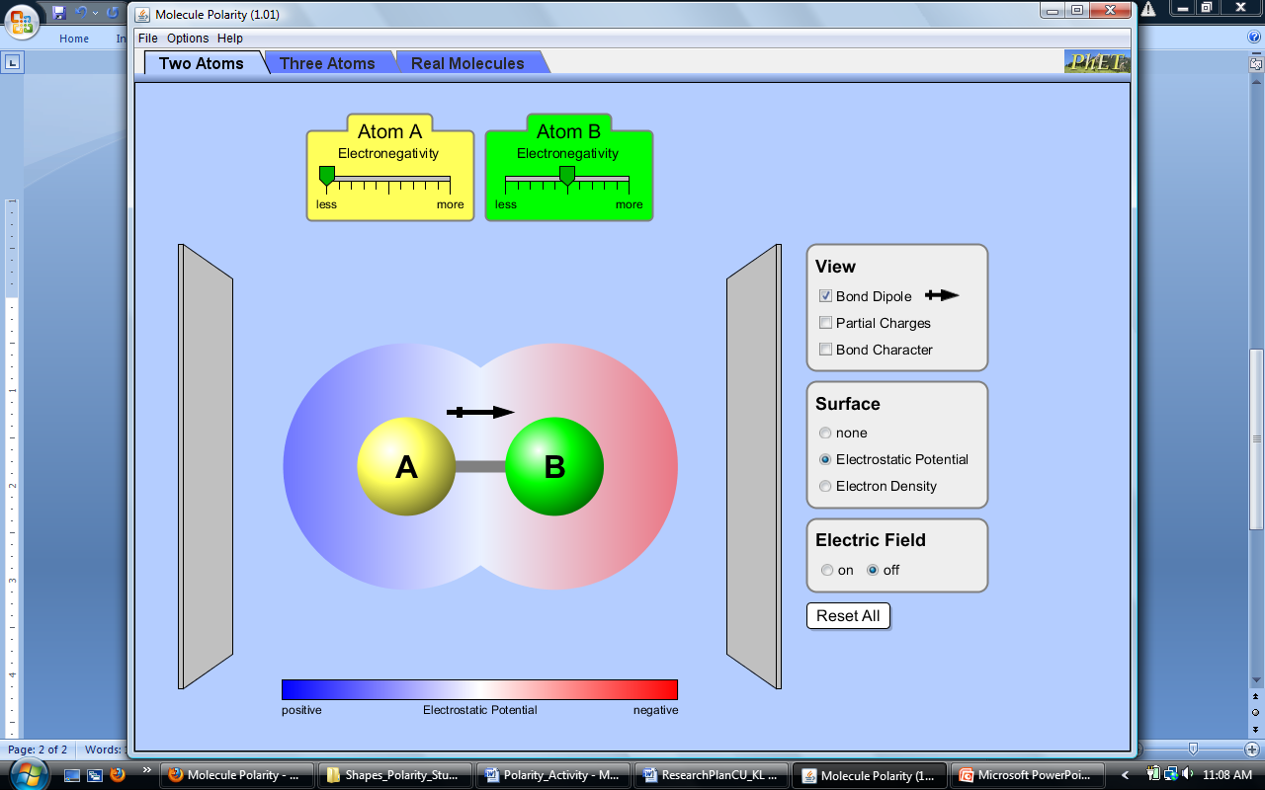

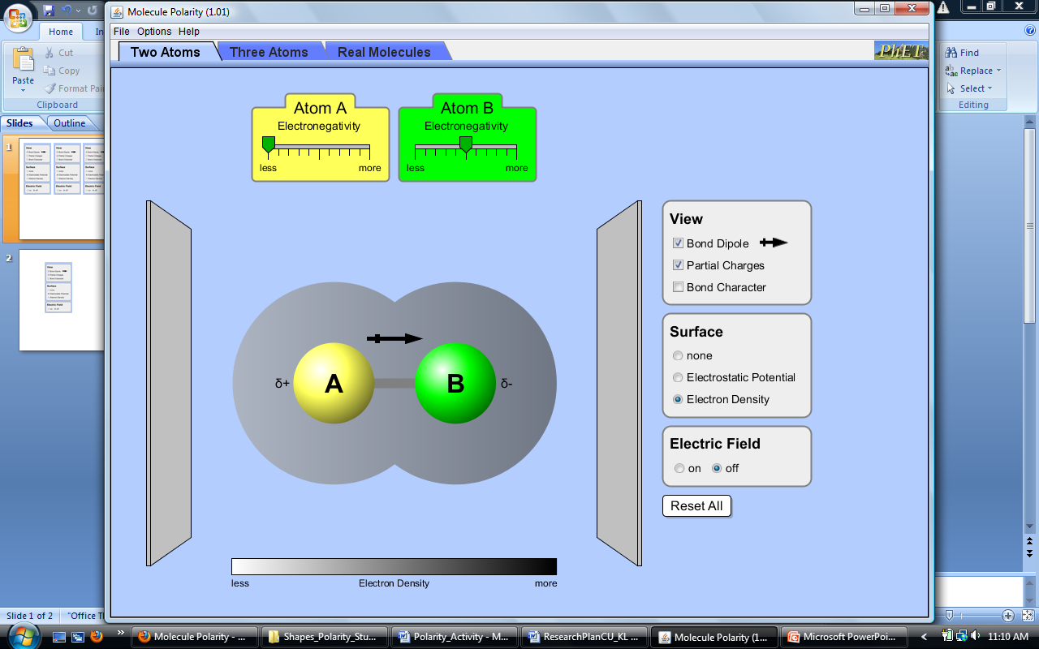





**Three Atoms** tab (Molecule Polarity)

1. Describe any new ways you can change the polarity of the three-atom molecule.

the position of the three atoms.

1. Explain the relationship between the bond dipoles and the molecular dipole.

Molecular is the vector sum of the bond dipoles.

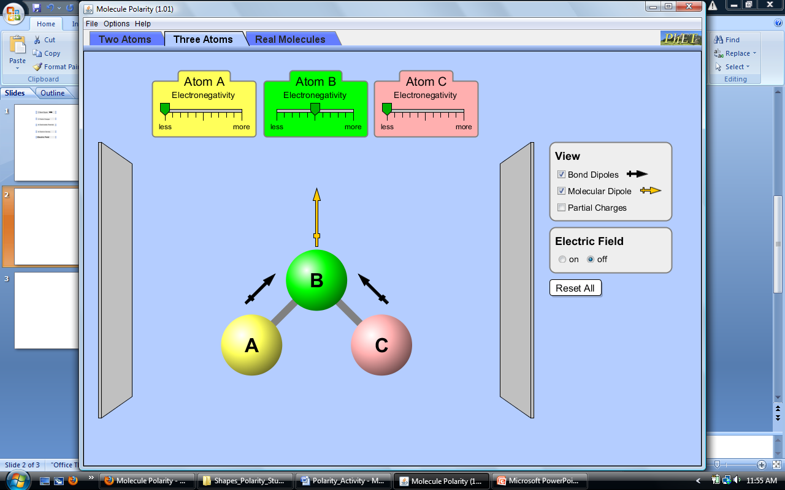

1. Can a non-polar molecule contain polar bonds? Explain your answer with an example.

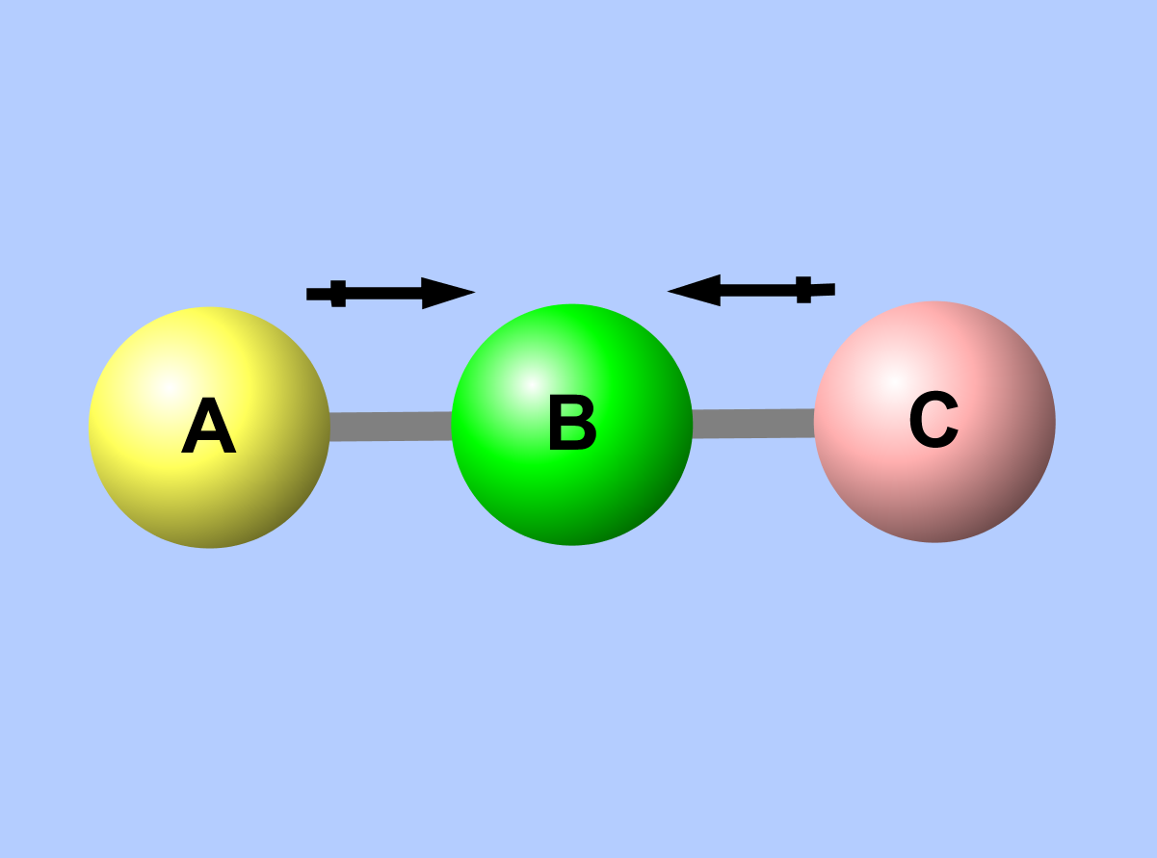Yes, when the polar bonds counteract with each other.

**Real Molecules** tab

1. **Predict** the polarity of 6 real molecules. First, draw the molecules and any bond dipoles. Then draw any molecular dipoles. Explain your reasoning before you check your predictions with the simulation.